

**Faculty of engineering - Shoubra**

**Benha University**

**Research Article / Research Project / Literature Review**

in fulfillment of the requirements of

|  |  |
| --- | --- |
| **Department** | **Engineering Mathematics and Physics** |
| **Division** | **-----------** |
| **Academic Year** | **2019-2020 Preparatory** |
| **Course name** | **Computer** |
| **Course code** | **ECE001** |

**Title: -**

**Build a website on recent computer engineering topics**

By:

|  |  |  |  |  |  |
| --- | --- | --- | --- | --- | --- |
|  | Name | | Edu mail | B.N | |
| 1 | محمد مجدي محمد محمود | muhammed195877@feng.bu.eg | | | 785 |

**Approved by:**

|  |  |
| --- | --- |
| Examiners committee | Signature |
| Dr.Ahmed Bayoum |  |
| Dr.Shady Elmashad |  |
| Dr. Abdelhamid Attaby |  |

**Application brief:**

**An operating system (OS) is machine software that administers computer hardware, computing resources,** **and provides common services for computer programs.** **Time-sharing operating systems schedule activities for efficient device use, which may include accounting software for processor time allocation, data storage, printing, and other resources.** **The operating system serves as an intermediary between programs and computer hardware for hardware functions such as input and output, and memory allocation, while the application code is typically performed directly by the hardware and sometimes makes system calls to or is interrupted by an OS task.** **Most machines are fitted with operating systems-from cell phones and video game consoles to web servers and supercomputers.** **A distributed operating system manages a group of independent, networked computers and makes them appear to be a single machine, as all computations are distributed (divided among the components).** **The dominant desktop operating system is Microsoft Windows with a market share of around 82.74%. Mac OS by Apple Inc. is in second place (13.23%), and the varieties of Linux are collectively in third place (1.57%). In the mobile sector (including smartphones and tablets), Android's share is up to 70% in the year 2017. According to third quarter 2016 data, Android's share on smartphones is dominant with 87.5 percent with also a growth rate of 10.3 percent per year, followed by Apple's iOS with 12.1 percent with per year decrease in market share of 5.2 percent, while other operating systems amount to just 0.3 percent. Linux distributions are dominant in the server and supercomputing sectors. Other specialized classes of operating systems, such as embedded and real-time systems, exist for many applications.**

**Screenshots:**

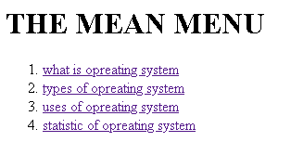

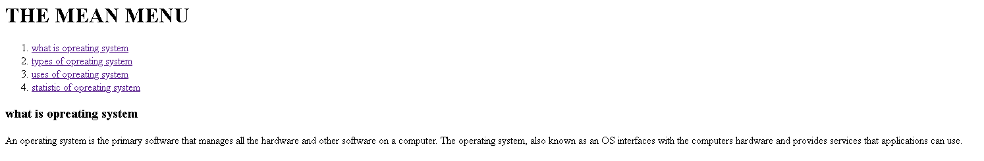

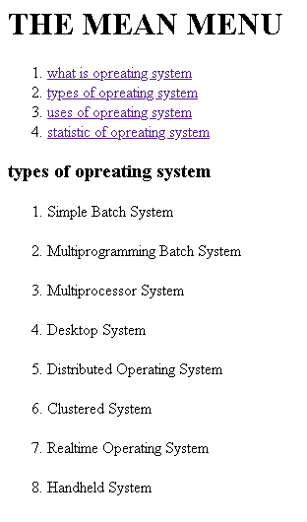

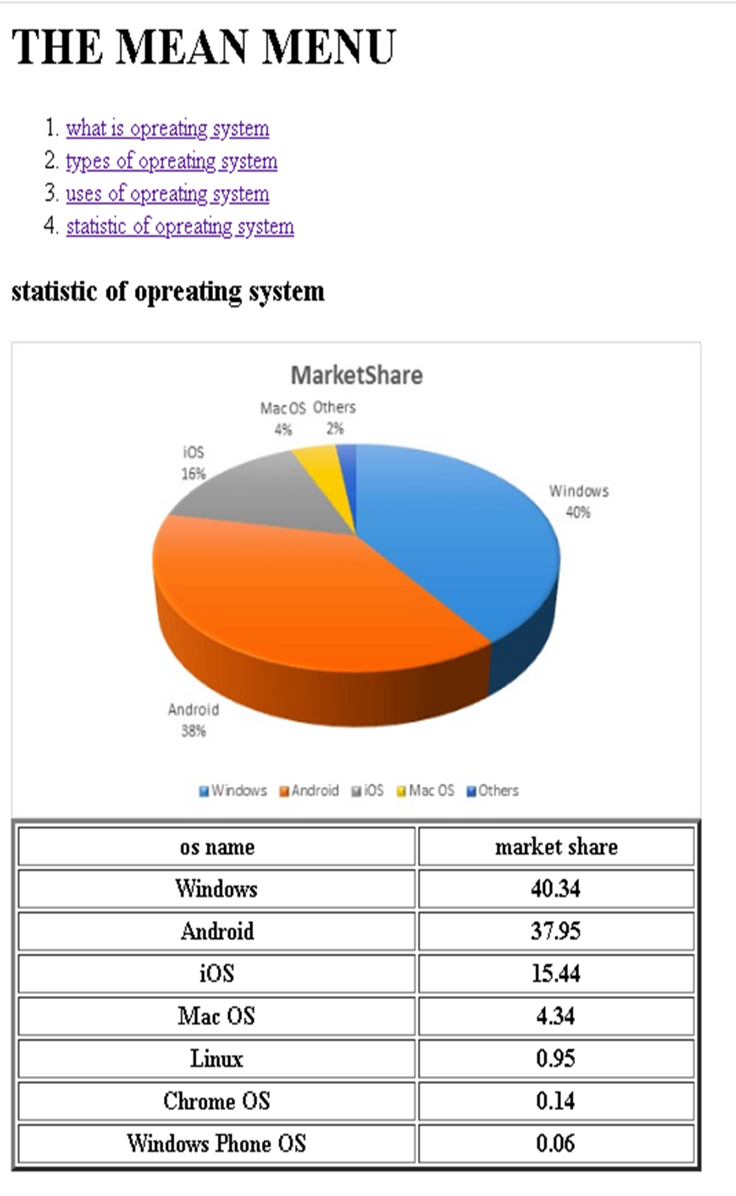

**Source code:**



